Name of your food drive | 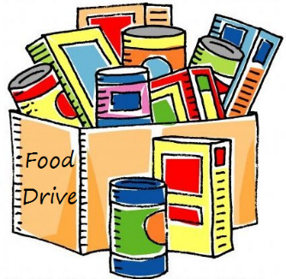
When
Organization Name is supporting Catonsville Emergency Assistance (CEA). By donating food you can support local families that rely on CEA. Together we can help our neighbors in need.
Our Goal
We would like to collect ___ pounds of food and dry goods. Please join in our efforts to meet this goal. We are also accepting monetary donations that will go directly to CEA.
Collection Site(s)
- _____________________________________
- _____________________________________
- _____________________________________
Please drop off donations between the hours of ____ and ____
Most Needed Items
Canned meat • Canned fruit • Canned veggies • Peanut butter • Jelly/jam • Tomato products
Cereal • Pasta • Rice • Beans • Coffee • Tea • Pancake mix • Pancake syrup

Low sodium foods and low sugar cereals are preferred.
No open items, homemade items, perishable items, or food over a year old.
Questions?
Contact __________________________ at (___)______
or _______________@____________.com

Catonsville Emergency Assistance serves greater Catonsville residents with emergency food, eviction prevention, and utility cut-off intervention. It is located at 25 Bloomsbury Avenue, Catonsville, MD 21228. 410-747-4357. www.catonsvillehelp.org.

